Evaluating Immunohistochemical Expression of Junctional Adhesion Molecule - A (JAM- A) In Multiple Myeloma
Abstract:
Background: Multiple myeloma accounts for 1% of all cancers and approximately 10% of all hematologic malignancies. JAM-A regulates cell growth and differentiation, while its aberrant expression or deregulation confers a more aggressive phenotype with poor prognosis in different types of human cancers, including multiple myeloma
Aim: to evaluate the immunohistochemical expression of JAM-A in cases of multiple myeloma and assess its possible role in bone marrow biopsies as regard the available clinic-pathological data to clarify its role in target therapy.
Material and method: This is a selected retrospective study including 40 different cases of MM.
Results:JAM-A has a significant statistical correlation between JAM-A expression and Age, histopathologhical types, Pattern of infiltration, BMB cellularity, ISS Stage, R- ISS Stage, Complete response, Resistance, Karyotyping result, short one year survival and overall survival (P= .022, =.020, =.016, =.017,=.033, =.042, =.008,= .032, =.019,= .012 and= .014 respectively ).
Conclusion: JAM-A overexpression might have an important role in proliferation, progression, aggressiveness, poor outcome and resistance to treatment of multiple myeloma cases. So, JAM-A has major targeting and promising value in prognosis and treatment of MM.
Keywords: Junctional Adhesion Molecule – A, Multiple myeloma.
Introduction:
Multiple Myeloma (MM) is a major health incurable problem and one of the highly aggressive hematological malignancies. It originates as result of clonal expansion of malignant plasma cells in the bone marrow ⁽¹⁾.
According to GLOBOCAN 2020, MM comes in 22th rank among worldwide malignancies. In Egypt, the newly cases of MM represent 0.55% of all malignancies⁽ ²⁾.
Obesity, advancing age, male sex, black race, genetic susceptibility, chronic immune stimulation or autoimmune pathology, family history and genetic variation are risk factors to MM ⁽³⁾.
Multiple Myeloma arises from the pre-neoplastic forms of the monoclonal gammopathy of undetermined significance (MGUS) with the 5% of risk to progress into MM in 5 years, and the smoldering myeloma (SMM) with 50% of progression risk. ⁽⁴⁾.
From a pathological view, MM composed of at least 10% of clonal plasma cells which may be focal, interstitial or diffuse with morphological types which may be mature, immature, blasmablastic and anaplastic types. As showen in figure 1 (A, B, C, D) ⁽⁵⁾
Junctional adhesion molecule –A (JAM-A) is a type 1 transmembrane glycoprotein belong to the immunoglobulin superfamily ⁽⁶⁾. JAM-A has been proved to have prognostic role in a number of tumors ⁽⁷⁾.
This study aims to evaluate the immunohistochemical expression of JAM-A in cases of MM and assess its possible role in examined bone marrow biopsies as regard the available clinic-pathological data.
Material and methods:
Study group:
This is a retrospective study including 40 cases of Multiple Myeloma. The material included archival formalin fixed paraffin embedded blocks were selected retrograde from 2018 till 2019. The patients were recruited from the clinical pathology Department, National Cancer Institute, and Cairo University. The Control cases were 7 cases who does not have the diseases, confirmed by other standard techniques.
Clinicopathological data were collected from the files of patients in form of age, sex,laboratory data , karyotyping, ISS staging systems (8), R-ISS staging system (9), complete response to therapy , resistance ,relapse and one year survival . The study was approved by the Research Ethical committee of Faculty of Medicine, Benha University, Egypt (MSC: 15-9-2022)
Material and Methods
A-Histopathologica1 Examination: Formalin-fixed and paraffin-embedded blocks were cut at 5 μm thickness and stained with hematoxylin and eosin. Two observers reviewed the microscopic sections from all the cases and were unaware of their diagnosis ⁽¹⁰⁾.
Inclusion criteria including the following
- Egyptians.
- Either sex is eligible.
- Ages of patients are above 18 years old.

Exclusion criteria included the following
- Less than 18 years old patients.
- Localized plasma cell lesions without bone marrow involvement.
- If the initial clinical information was absent.
- Non Egyptian patients.
- History of chemotherapy.
Immunohistochemical studies:
JAM-A staining was performed using streptavidin-Biotin technique in accordance with guidelines provided by the manufacturer (Biospes, China). As a chromagen, the slices were stained with 0.02% diaminobenzine (DAB) solution. Sections were then dehydrated, mounted and counterstained with hematoxylin.
Sections were incubated with the diluted primary Rabbit polyclonal antibody (1:20) for JAM-A at 4°Cover night. A section of normal endometrium was used as external positive control. Negative control for all markers was achieved by omitting the primary antibody.
Table (1): Data for using JAM-A antibody in studied cases:

Antibody | Type | Source | Dilution | Positive control | Incubation | Antigen retrival
JAM-A | monoclonal | Biospes, China | 1:20 | normal endometrium | at 4°Cover night | Protein A affinity purified

Interpretation of JAM- A expression:
- Positivity was considered as brownish homogenous membranous staining of tumor cells ⁽¹¹⁾.
- The intensity of JAM- A membranous staining was scored with regards to both the extent and intensity of staining according to ⁽¹²⁾. The final score was calculated by multiplying the intensity and percentages scores. Cases less than or equal to 6 were considered to be low expressed and greater than 6 were considered to be highly expressed. Survival data were plotted as Kaplan – Meier curves and statistical significance was determined by log- rank test. The follow- up time of 12 months.
Statistical analysis:
Results were analyzed using SPSS (SPSS Inc., Chicago, IL, USA) (version 22) statistical package for Microsoft Windows as follows: P value >0.05 is no significant (N), P<0.05 is significant, and P≤ 0.01 is highly significant.

Results:
Clinicopathological results:
The age of 40 studied cases ranged from 22-74 years with the mean age was 53.53±SD10.046. Multiple myeloma cases included 70% of the studied patients < 60 years old while 30% were ≥60 years old
The characteristics of the patients and tumors are listed in (Table 2).
There was a significant statistical relation between histopathological type of MM and pattern of infiltration, BMB cellularity and ISS Stage (Table 2).
Table (2): Relation between histopathological types of MM and different parameters in studied cases:
P value | Histopathological type of MM |  |  |  |  | parameters
P value | Other types  n=7(%) | Immature  n=8(%) | Mature  n=25(%) | Total  n=40
0.257 | 6(21.5)  1(8) | 6(21.5)  2(16) | 16(57)  9(75) | 28  12 | Age  <60  ≥60
0.337 | 4(15)  3(21) | 4(15)  4(29) | 18(70)  7(50) | 26  14 | Sex  Male  Female
0.042* | 0(0)  3(18)  4(22) | 0(0)  2(11)  6(33.5) | 5(100)  12(71)  8(44.5) | 5  17  18 | Pattern of infiltration  Patchy  Interstitial  diffuse
0.020* | 0(0)  7(24) | 1(9)  7(24) | 10(91)  15(52) | 11  29 | BMB cellularity  Normocellular  Hypercellular
0.465 | 2(12)  5(21) | 3(19)  5(21) | 11(69)  14(58) | 16  24 | Pathological fracture  Yes  No
0.698 | 6(18)  1(17) | 6(17)  2(33) | 22(65)  3(50) | 34  6 | Anemia  Yes  No
0.688 | 1(20)  6(19)  0(0) | 0(0)  8(25)  0(0) | 4(80)  18(56)  3(100) | 5  32  3 | Calcium level  -Low  -Normal  -High
0.719 | 4(15)  3(23) | 6(22)  2(15) | 17(63)  8(62) | 27  13 | Creatinine level  -Normal  -High
0.258 | 1(7)  6(23) | 3(19)  5(21) | 10(72)  15(58) | 14  26 | Urea level  -Normal  -High
0.692 | 3(15)  4(20) | 6(30)  2(10) | 11(55)  14(70) | 20  20 | LDH level  -Normal  -High
1.000 | 0(0)  1(6)  6(28.6) | 1(50)  1(6)  6(28.6) | 1(50)  15(88)  9(42.9) | 2  17  21 | B2microglobulin level  -Low  -Normal  -High
0.564 | 5(24)  2(10.5) | 3(14)  5(26) | 13(62)  12(64) | 21  19 | Albumin level  -Low  -Normal
0.014* | 0(0)  4(16)  3(60) | 2(18)  6(25)  0(0) | 9(82)  14(59)  2(40) | 11  24  5 | ISS Stage  Stage 1  Stage 2  Stage 3
0.942 | 1(8)  5(24)  1(14) | 3(25)  5(24)  0(0) | 8(67)  11(52)  6(86) | 12  21  7 | R- ISS Stage  Stage 1  Stage 2  Stage 3
0.382 | 3(11)  2(25)  2(40) | 7(26)  1(12.5)  0(0) | 17(63)  5(62.5)  3(60) | 27  8  5 | Free light chain  No  Kappa  Lambda
0.484 | 7(18)  0(0) | 8(20.5)  0(0) | 24(61.5)  1(100) | 39  1 | Heavy chain  IG g  IG A
0.794 | 4(17)  3(17) | 4(17)  4(24) | 15(65)  10(59) | 23  17 | Complete response  Yes  No
0.178 | 0(0)  7(26) | 4(31)  4(15) | 6(69)  16(59) | 13  27 | Resistance  Yes  No
0.107 | 3(16)  4(19) | 6(31.5)  2(9.5) | 10(52.5)  15(71.5) | 19  21 | Relapse  Yes  No
0.264 | 1(17)  3(18)  3(18) | 0(0)  2(12)  6(35) | 5(83)  12(70)  8(47) | 6  17  17 | Karyotyping  Hypodiploid  Diploid  Hyperdiploid
0.618 | 3(33.5)  4(13) | 2(22)  6(19) | 4(44.5)  21(68) | 9  31 | One year survival  dead  free
*significant, BMB: bone marrow biopsy, ISS: international staging system. R-ISS: revised- international staging system

Immunohistochemical Results:
JAM-A expression in studied groups:
For MM cases, all cases were JAM-A positive, (47.5%) were with low JAM-A expression and (52.5%) were with high JAM-A expression.
Relation between JAM-A expression score and different clinicopathological parameters of studied MM cases:
There was a significant statistical correlation between JAM-A expression and Age ( p=0.022.), histopathologhical types (p=0.025) with 64% of mature type showing low JAM-A expression, 62.5% of immature type showing high JAM-A expression and 71% of other types showing high JAM-A expression ,Pattern of infiltration(p=0.016), BMB cellularity(p=0.017), ISS Stage(p=0.033), R- ISS Stage(p=0.042), Complete response(p=0.008), Resistance(p=0.032), Karyotyping result(p=0.019), one year survival(p=0.012) (Table 3) &( Figure 2).
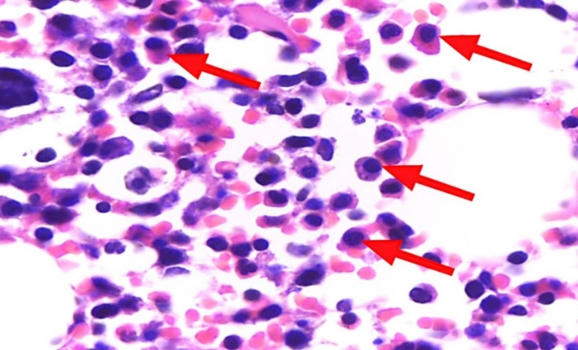  A | 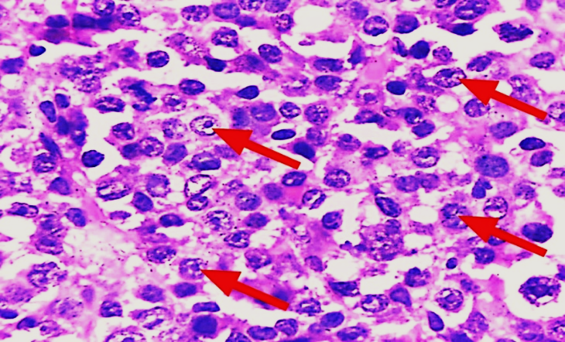  B
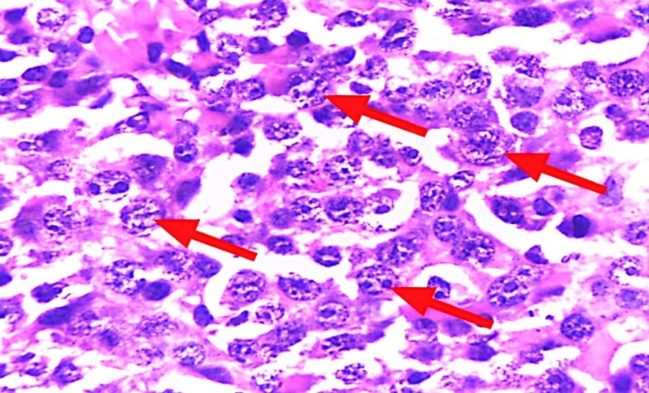  C | 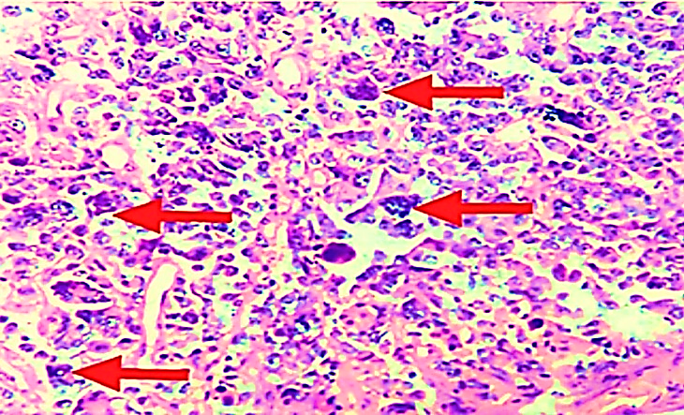  D
Figure (1): Histopathological types of multiple myeloma: (A): mature type , malignant plasma cells with eccentrically placed nuclei, mature chromatin and abundant basophilic cytoplasm (red arrow), H&E stain x1000. (B): immature type , malignant plasma cells with eccen-trically located large nucleus with one or several nu-cleoli, diffuse chromatin pattern, perinuclear clear area,and variable amount of blue cytoplasm (red arrow), H&E stain x1000. (C): plasmablastic type , malignant plasma cells with fine chromatin, increased nuclear size, large nucleoli and scant cytoplasm (red arrow), H&E stain x1000. (D): anaplastic type , malignant plasma cells with bizarre nuclei and purple bluish granular cytoplasm (red arrow), H&E stain x1000.

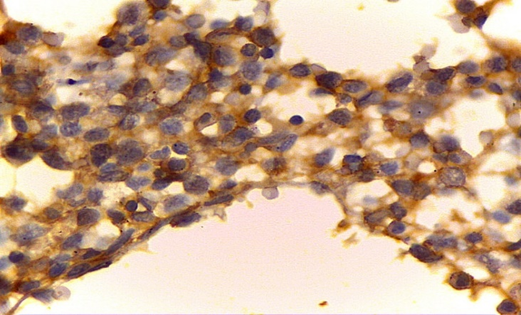  A | 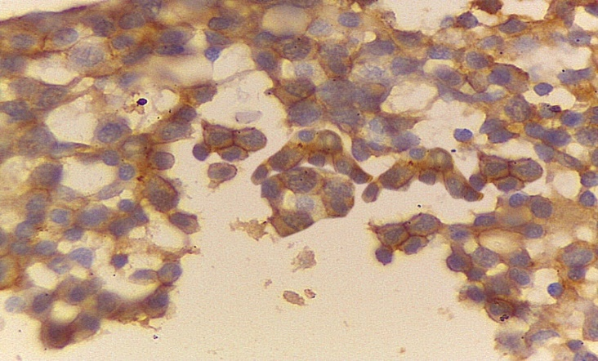  B
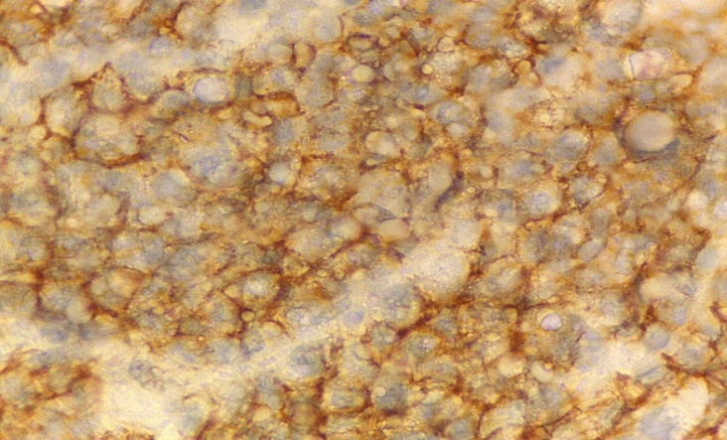  C | 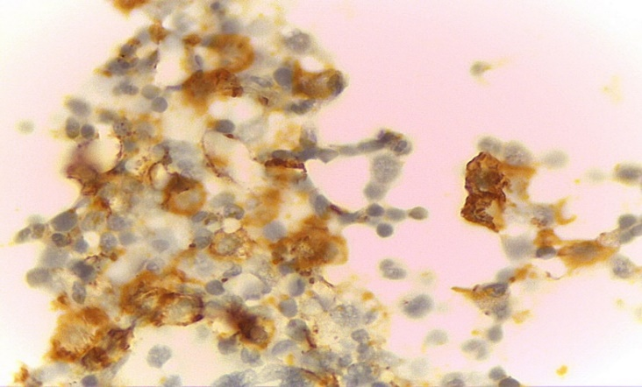  D
Figure (2): Immunohistochemical expression of JAM-A in studied cases: (A): MM, Mature type, Positive for JAM_A with score 6. (B): MM, immature type, positive for JAM_A with score 12. (C): MM, Plasmablastic type, positive for JAM_A with score 12. (D): MM, Anaplastic type, positive for JAM_A with score 9.
Table (3): Relation between JAM-A expression and different parameters in studied MM cases.
P value | JAM-A score |  |  | parameters
P value | High  n=21(%) | Low  n=19(%) | Total  n=40 | parameters
0.022* | 18(64)  3(25) | 10(36)  9(75) | 28  12 | Age  <60  ≥60
0.822 | 14(54)  7(50) | 12(46)  7(50) | 26  14 | Sex  Male  Female
0.025* | 9(36)  5(62.5)  5(71) | 16(64)  3(37.5)  2(29) | 25  8  7 | Histopathologhical types of MM  Mature  Immature  Other types
0.016* | 0(0)  9(53)  12(67) | 5(100)  8(47)  6(33) | 5  17  18 | Pattern of infiltration  Patchy  Interstitial  diffuse
0.017* | 2(20)  18(60) | 8(80)  12(40) | 10  30 | BMB cellularity  Normocellular  Hypercellular
0.707 | 9(56)  12(50) | 7(44)  12(50) | 16  24 | Pathological fracture  Yes  No
0.464 | 17(50)  4(67) | 17(50)  2(33) | 34  6 | Anemia  Yes  No
0.511 | 3(60)  17(53)  1(33) | 2(40)  15(47)  2(67) | 5  32  3 | Calcium level  -Low  -Normal  -High
0.909 | 14(52)  7(54) | 13(48)  6(46) | 27  13 | Creatinine level  -Normal  -High
0.285 | 9(64)  12(46) | 5(36)  14(54) | 14  26 | Urea level  -Normal  -High
0.355 | 12(60)  9(45) | 8(40)  11(55) | 20  20 | LDH level  -Normal  -High
0.990 | 2(100)  7(41)  12(57) | 0(0)  10(59)  9(43) | 2  17  21 | B2microglobulin level  -Low  -Normal  -High
0.988 | 11(52)  10(53) | 10(48)  9(47) | 21  19 | Albumin level  -Low  -Normal
0.033* | 3(27)  14(58)  4(80) | 8(73)  10(42)  1(20) | 11  24  5 | ISS Stage  Stage 1  Stage 2  Stage 3
0.042* | 7(58)  14(67)  0(0) | 5(42)  7(33)  7(100) | 12  21  7 | R- ISS Stage  Stage 1  Stage 2  Stage 3
0.499 | 14(52)  3(37.5)  4(80) | 13(48)  5(62.5)  1(20) | 27  8  5 | Free light chain  No  Kappa  Lambda
0.299 | 21(54)  0(0) | 18(46)  1(100) | 39  1 | Heavy chain  IG g  IG A
0.008* | 8(35)  13(76.5) | 15(65)  4(23.5) | 23  17 | Complete response  Yes  No
0.032* | 10(77)  11(41) | 3(23)  16(59) | 13  27 | Resistance  Yes  No
0.209 | 12(63)  9(43) | 7(37)  12(57) | 19  21 | Relapse  Yes  No
0.019* | 3058)  4(23.5)  14(82) | 3(50)  13(76.5)  3(18) | 6  17  17 | Karyotyping  Hypodiploid  Diploid  Hyperdiploid
0.012* | 8(89)  13(42) | 1(11)  18(58) | 9  31 | one year survival  dead  free
*significant, BMB: bone marrow biopsy, ISS: international staging system, R-ISS: revised- international staging system

Discussion
JAM-A regulates cell growth and differentiation, while its aberrant expression or deregulation confers a more aggressive phenotype with poor prognosis in different types of human cancers, including multiple myeloma. ⁽¹³⁾.
The current study revealed a statistically significant relation between JAM-A expression and age of studied MM cases (p =.022). This was compatible with a study on MM ⁽¹⁴⁾.
This disagreed with a previous study ⁽¹⁵⁾ reported that JAM-A was insignificantly correlated with age of studied cases. This can be explained by the difference in the age group between their studies and our study.
The current study researched; there was no statistically significant correlation between JAM-A overexpression and sex of studied MM cases (p =.822). This agreed with previous studies ^{(16) & (17)} on non-small cell lung cancer and MM.
Another statistically significant positive relation was reached, between JAM-A overexpression and pattern of infiltration (p =.016), BMB cellularity (p =.017) and variant of MM (p =.025). This agreed with studies on MM ^{(17) & (18)} who reported that diffuse pattern of infiltration, immature cell morphology and higher bone marrow cellularity is correlated with higher ISS stages and also JAM-A overexpression is correlated with higher ISS stages. So, this might suggest a relation between the previous included histopathological parameters and JAM-A overexpression. So, whenever JAM-A is overexpressed, increase growth, proliferation and survival of MM cells ⁽¹³⁾
A statistically insignificant correlation was found between JAM-A overexpression and Pathological fracture (p =.707). A previous study was in a line with our result ⁽¹⁴⁾.
In contrast, previous studies ⁽¹⁹⁾ ⁽²⁰⁾ ⁽²¹⁾ reported that whenever the volume of MM tumor increased , increased cytokine secretion, increased RANKL and IL-6 causing bone destruction and pathological fracture; all this with JAM-A overexpression.
There was statistically insignificant correlation between JAM-A overexpression with anemia (p =.464), calcium level (p =.511), creatinine (p =.909), urea level (p =.285), LDH level (p =.355) and B2 microglobulin level (p =.990), this was in line with a study on MM ⁽²¹⁾.
But, studies on MM ⁽¹⁹⁾ ⁽²⁰⁾ showed that JAM-A overexpression associated with hypercalcemia. This disparency may be due to 80% of cases were normal calcium level.
This disagreed with a study on MM reported that there was a significant correlation with b2 microglobulin ⁽²¹⁾, this can be explained by difference in number of cases with elevated B2 microglobulin associated with high JAM-A overexpression.
In this current study, however 52% of studied MM cases with low albumin level showing JAM-A overexpression, the correlation was statistically insignificant (p =.988), this was in a line with previous studies ⁽²²⁾ ⁽²³⁾ reporting that the albumin level in MM reflect tumor cell burden, which is mainly associated with cytokine induced impairement of albumin synthesis and excessive degradation.
This statistically insignificant correlation might be due to low number of studied cases and different follow up periods.
In the present study, a statistically significant positive relation was found between JAM-A expression with ISS stages (p =.033) & R-ISS staging of MM (p =.042). This was compatible with other studies ⁽¹³⁾ ⁽¹⁴⁾ reporting that high JAM-A expression is related to higher ISS stage in MM. In addition, previous studies found that high JAM-A expression was correlated to higher ISS stage of diffuse large B cell lymphoma and epithelial ovarian cancer ⁽²⁴⁾ ⁽²⁵⁾, respectively.
A study on MM revealed the important role of JAM-A in bone marrow microenvironment leading to tumor progression and metastasis through regulation of intracellular signaling cascades responsible for tumorigenesis and metastasis. This may be pursuant to the critical role of JAM-A in promoting tumor progression as it leads to tumor invasion and metastasis ⁽²⁶⁾.
This disagreed with previous study ⁽²¹⁾ who reported that there was insignificant relation between ISS stage of MM and JAM-A expression which was explained by difference in number of cases with high JAM-A expression in higher stages (II-III) between both studies.
In this work, JAM-A overexpression was insignificantly related to free light chain (p =.499) and heavy chain (p =.299) in studied MM cases.
Inversely with this finding, other results carried out by ⁽¹⁴⁾ ⁽¹⁷⁾ ⁽²⁷⁾ on MM reported that lambda light chain restriction was higher in high-risk patients of MM which had higher ISS stage. This can be explained by most of our cases showing no free light chain (67.5%).
This was compatible with studies on MM reported that no dramatic difference in heavy chain types when made comparison between high and low risk groups ^{(17) (27).}
In this work, there was inverse correlation between JAM-A overexpression and the complete response of MM cases (p =.008) as 76.5% of JAM-A overexpression has no complete response. In agreement with this finding, a study on diffuse large B cell lymphoma reported that Patients with high JAM-A expression tended to have low complete remission rate ^{(24).}
Another statistically significant correlation was reached, between JAM-A overexpression and resistance to treatment (p =.032) as 77% of resistant cases was JAM-A overexpression. This was in alignment with on MM ^{(21) (28).}
Resistance acquired by MM cells to anti-cancer drugs occurs through functional and physical interactions with the BM microenvironment via two interrelated mechanisms. Firstly, Bone marrow stromal cells (BMSCs) give rise to soluble factors as IL-6 which activates downstream signal transduction pathways causing drug resistance. Secondly, they increase the expression of several molecules as cell cycle inhibitors and anti-apoptotic members of the Bcl-2 family in myeloma cells consequent to direct adhesion ^{(21).}
Also, a study on MM founded that there was a significant correlation between JAM-A overexpression and IL-6 ⁽²¹⁾, so this suggested a correlation between JAM-A overexpression n and drug resistance.
In this work, however 63% of relapsed MM cases was JAM-A overexpression but had no significant correlation (p =.209). Studies on MM revealed that relapse is more common with high JAM-A expression as this overexpression mostly associated with resistance to treatment which a cause to relapse as reported in other studies on MM ^{(14) (21) (28).‏}
Also, a study on the glioblatoma reporting that JAM-A expression was significantly higher in recurrent glioblatomas (GBMs) than primary GBMs (p < 0.001) ^{(29).}
The current study reached a statistically significant relation between JAM-A overexpression and karyotyping result (p =.019). This agreed with studies reporting that 70.8% of genetic high-risk patients had membrane JAM-A levels above the median at the day of biopsy; this percentage decreased in the genetic intermediate risk group to 46.2% and among the standard genetic risk patients to 34% ^{(14) (21).}
In this work, JAM-A overexpression was significantly related to one year survival in studied MM cases (p =.012). Also, after kaplen-Meier survival analysis, we founded that patients with high expression of membrane JAM-A had a significant lower survival than patients with low expression of membrane JAM-A (p =.014). In accordance with this finding, other studies reported that the median progresssion free survival differed significantly in subjects with higher membrane JAM-A expression levels than the median. This difference was deemed statistically significant ( P=0.0022) ⁽¹³⁾ ⁽¹⁴⁾ ⁽¹⁵⁾ ⁽³⁰⁾. In addition, other studies revealed that JAM-A overexpression is associated with shorter survival in ovarian cancer, lung cancer and breast cancer ⁽¹⁵⁾ ⁽²⁵⁾ ⁽³¹⁾, respectively.
In contrast, previous studies founded that low JAM-A expression is associated with poor outcomes and short overall survival in pancreatic cancer, gastric cancer and endometrial cancer ⁽³²⁾ ⁽³³⁾ ⁽³⁴⁾, respectively. The prognostic value of JAM-A expression in cancers may be organ specific ^{(33) (34).}
Conclusion: JAM-A overexpression might have an important role in proliferation, progression, aggressiveness, poor outcome and resistance to treatment of multiple myeloma cases. So, JAM-A has major targeting and promising value in prognosis and treatment of MM.

Refrences
  - Barankiewicz, J., Szumera-Ciećkiewicz, A., Salomon-Perzyński, A., Wieszczy, P., Malenda, A., Garbicz, F., ... & Lech-Marańda, E. (2021). The CRBN, CUL4A and DDB1 Expression Predicts the Response to Immunomodulatory Drugs and Survival of Multiple Myeloma Patients. Journal of clinical medicine, 10(12), 2683.
  - Sung, H., Ferlay, J., Siegel, R. L., Laversanne, M., Soerjomataram, I., Jemal, A., & Bray, F. (2021). Global cancer statistics 2020: GLOBOCAN estimates of incidence and mortality worldwide for 36 cancers in 185 countries. CA: a cancer journal for clinicians, 71(3), 209-249.
  - Chang, V. C., Khan, A. A., Huang, W. Y., Katki, H. A., Purdue, M. P., Landgren, O., & Hofmann, J. N. (2022). Body mass index and risk of progression from monoclonal gammopathy of undetermined significance to multiple myeloma: Results from the Prostate, Lung, Colorectal and Ovarian Cancer Screening Trial. Blood cancer journal, 12(4), 1-4.
  - Saltarella, I., Apollonio, B., Lamanuzzi, A., Desantis, V., Mariggiò, M. A., Desaphy, J. F., ... & Frassanito, M. A. (2022). The Landscape of lncRNAs in Multiple Myeloma: Implications in the “Hallmarks of Cancer”, Clinical Perspectives and Therapeutic Opportunities. Cancers, 14(8), 1963.
  - Fitzpatrick, M. J., Nardi, V., & Sohani, A. R. (2021). Plasma cell myeloma: role of histopathology, immunophenotyping, and genetic testing. Skeletal Radiology, 1-14.
  - Solimando, A. G., Brandl, A., Mattenheimer, K., Graf, C., Ritz, M., Ruckdeschel, A., ... & Beilhack, A. (2018). JAM-A as a prognostic factor and new therapeutic target in multiple myeloma. Leukemia, 32(3), 736-743.
  - Murakami, T., Takasawa, A., Takasawa, K., Akimoto, T., Aoyama, T., Magara, K., ... & Osanai, M. (2021). Aberrant expression of junctional adhesion molecule‐A contributes to the malignancy of cervical adenocarcinoma by interaction with poliovirus receptor/CD155. Cancer science, 112(2), 906-917.
  - Hagen, P., Zhang, J., & Barton, K. (2022). High-risk disease in newly diagnosed multiple myeloma: Beyond the R-ISS and IMWG definitions. Blood Cancer Journal, 12(5), 83.
  - Hemminki, K., Försti, A., Houlston, R., & Sud, A. (2021). Epidemiology, genetics and treatment of multiple myeloma and precursor diseases. International journal of cancer, 149(12), 1980-1996.
  - Yesmin, I., Begum, F., Yunus, A., Kabir, A. L., & Baqui, M. N. (2019). Tag: Trephine biopsy. Journal of Histopathology and Cytopathology, 3(2), 134-142.‏
  - Murakami, T., Takasawa, A., Takasawa, K., Akimoto, T., Aoyama, T., Magara, K., ... & Osanai, M. (2021). Aberrant expression of junctional adhesion molecule‐A contributes to the malignancy of cervical adenocarcinoma by interaction with poliovirus receptor/CD155. Cancer science, 112(2), 906-917.‏
  - Upadhaya, P., Barhoi, D., Giri, A., Bhattacharjee, A., & Giri, S. (2019). Joint detection of claudin‐1 and junctional adhesion molecule‐A as a therapeutic target in oral epithelial dysplasia and oral squamous cell carcinoma. Journal of cellular biochemistry, 120(10), 18117-18127.‏
  - Solimando, A. G., Da Vià, M. C., Leone, P., Borrelli, P., Croci, G. A., Tabares, P., ... & Beilhack, A. (2021). Halting the vicious cycle within the multiple myeloma ecosystem: Blocking JAM-A on bone marrow endothelial cells restores angiogenic homeostasis and suppresses tumor progression. haematologica, 106(7), 1943.
  - Solimando, A. G., Brandl, A., Mattenheimer, K., Graf, C., Ritz, M., Ruckdeschel, A., ... & Beilhack, A. (2018). JAM-A as a prognostic factor and new therapeutic target in multiple myeloma. Leukemia, 32(3), 736-743.‏
  - Magara, K., Takasawa, A., Osanai, M., Ota, M., Tagami, Y., Ono, Y., ... & Sawada, N. (2017). Elevated expression of JAM‐A promotes neoplastic properties of lung adenocarcinoma. Cancer Science, 108(11), 2306-2314.
  - Zhang, M., Luo, W., Huang, B., Liu, Z., Sun, L., Zhang, Q., ... & Wang, E. (2013). Overexpression of JAM-A in non-small cell lung cancer correlates with tumor progression. PloS one, 8(11), e79173. progression. haematologica, 106(7), 1943.
  - Hao, Y., Khaykin, D., Machado, L., Van den Akker, T., Houldsworth, J., Barlogie, B., ... & Teruya-Feldstein, J. (2020). Bone marrow morphologic features, MyPRS, and gene mutation correlations in plasma cell myeloma. Modern Pathology, 33(2), 188-195
  - Mai, E. K., Hielscher, T., Kloth, J. K., Merz, M., Shah, S., Hillengass, M., ... & Hillengass, J. (2016). Association between magnetic resonance imaging patterns and baseline disease features in multiple myeloma: analyzing surrogates of tumour mass and biology. European radiology, 26, 3939-3948.
  - Du, J. S., Yen, C. H., Hsu, C. M., & Hsiao, H. H. (2021). Management of myeloma bone lesions. International Journal of Molecular Sciences, 22(7), 3389.
  - Lemaitre, L., Hamaidia, M., Descamps, J. G., Do Souto Ferreira, L., Joubert, M. V., Gadelorge, M., ... & Espagnolle, N. (2022). Toll-like receptor 4 selective inhibition in medullar microenvironment alters multiple myeloma cell growth. Blood Advances, 6(2), 672-678.‏
  - Shaaban, I. O. A., Sultan, H. K., Sultan, M. M., El Gammal, M. M., & Balbaa, O. A. (2023). Relation of junctional adhesion molecule-a in multiple myeloma patients with possible prognostic factors. The Egyptian Journal of Haematology, 48(2), 201-205.
  - Laudin, G. E., Levay, P. F., & Coetzer, B. (2020). Globulin fraction and albumin: globulin ratio as a predictor of mortality in a South African multiple myeloma cohort. International Journal of Hematologic Niesvizky, R., Flinn, I. W., Rifkin, R., Gabrail, N., Charu, V., Clowney, B., ... & Reeves, J. (2015). Oncology, 9(3), IJH27.‏
  - Cai, Y., Zhao, Y., Dai, Q., Xu, M., Xu, X., & Xia, W. (2021). Prognostic value of the albumin–globulin ratio and albumin–globulin score in patients with multiple myeloma. Journal of International Medical Research, 49(3), 0300060521997736.‏
  - Xu, P. P., Sun, Y. F., Fang, Y., Song, Q., Yan, Z. X., Chen, Y., ... & Zhao, W. L. (2017). JAM-A overexpression is related to disease progression in diffuse large B-cell lymphoma and downregulated by lenalidomide. Scientific reports, 7(1), 7433.‏
  - Ivana, B., Emina, M., Marijana, M. K., Irena, J., Zoran, B., & Radmila, J. (2019). High expression of junctional adhesion molecule-A is associated with poor survival in patients with epithelial ovarian cancer. The International Journal of Biological Markers, 34(3), 262-268.‏
  - Czubak-Prowizor, K., Babinska, A., & Swiatkowska, M. (2022). The F11 receptor (F11R)/junctional adhesion molecule-A (JAM-A)(F11R/JAM-A) in cancer progression. Molecular and Cellular Biochemistry, 477(1), 79-98.‏
  - van den Akker, T., Hao, Y., & Teruya-Feldstein, J. (2019). Correlation of bone marrow morphologic assessment and genetic aberrations in plasma cell myeloma with clinical outcomes. Growth, 3(33.7), 7-9.‏
  - Kelly, K. R., Espitia, C. M., Zhao, W., Wendlandt, E., Tricot, G., Zhan, F., ... & Nawrocki, S. T. (2015). Junctional adhesion molecule-A is overexpressed in advanced multiple myeloma and determines response to oncolytic reovirus. Oncotarget, 6(38), 41275.‏
  - Rosager, A. M., Sørensen, M. D., Dahlrot, R. H., Boldt, H. B., Hansen, S., Lathia, J. D., & Kristensen, B. W. (2017). Expression and prognostic value of JAM-A in gliomas. Journal of neuro-oncology, 135, 107-117.‏
  - Solimando, A. G., Da Via, M. C., Leone, P., Croci, G., Borrelli, P., Gaviria, P. T., ... & Beilhack, A. (2019). Adhesion-mediated multiple myeloma (MM) disease progression: Junctional adhesion molecule a enhances angiogenesis and multiple myeloma dissemination and predicts poor survival. Blood, 134, 855.‏
  - Magara, K., Takasawa, A., Takasawa, K., Aoyama, T., Ota, M., Kyuno, D., ... & Osanai, M. (2024). Multilayered proteomics reveals that JAM‐A promotes breast cancer progression via regulation of amino acid transporter LAT1. Cancer Science.‏
  - Fong D, Spizzo G, Mitterer M, Seeber A, Steurer M, Gastl G, Brosch I, Moser P (2012) Low expression of junctional adhesion molecule A is associated with metastasis and poor survival in pancreatic cancer. Ann Surg Oncol 19:4330–4336.
  - Huang, J. Y., Xu, Y. Y., Sun, Z., Wang, Z. N., Zhu, Z., Song, Y. X., ... & Xu, H. M. (2014). Low junctional adhesion molecule A expression correlates with poor prognosis in gastric cancer. Journal of Surgical Research, 192(2), 494-502.‏
  - Czubak-Prowizor, K., & Świątkowska, M. (2023). Junctional adhesion molecule-A (JAM-A) in gynecological cancers: Current state of knowledge. Biocell, 47(4).

